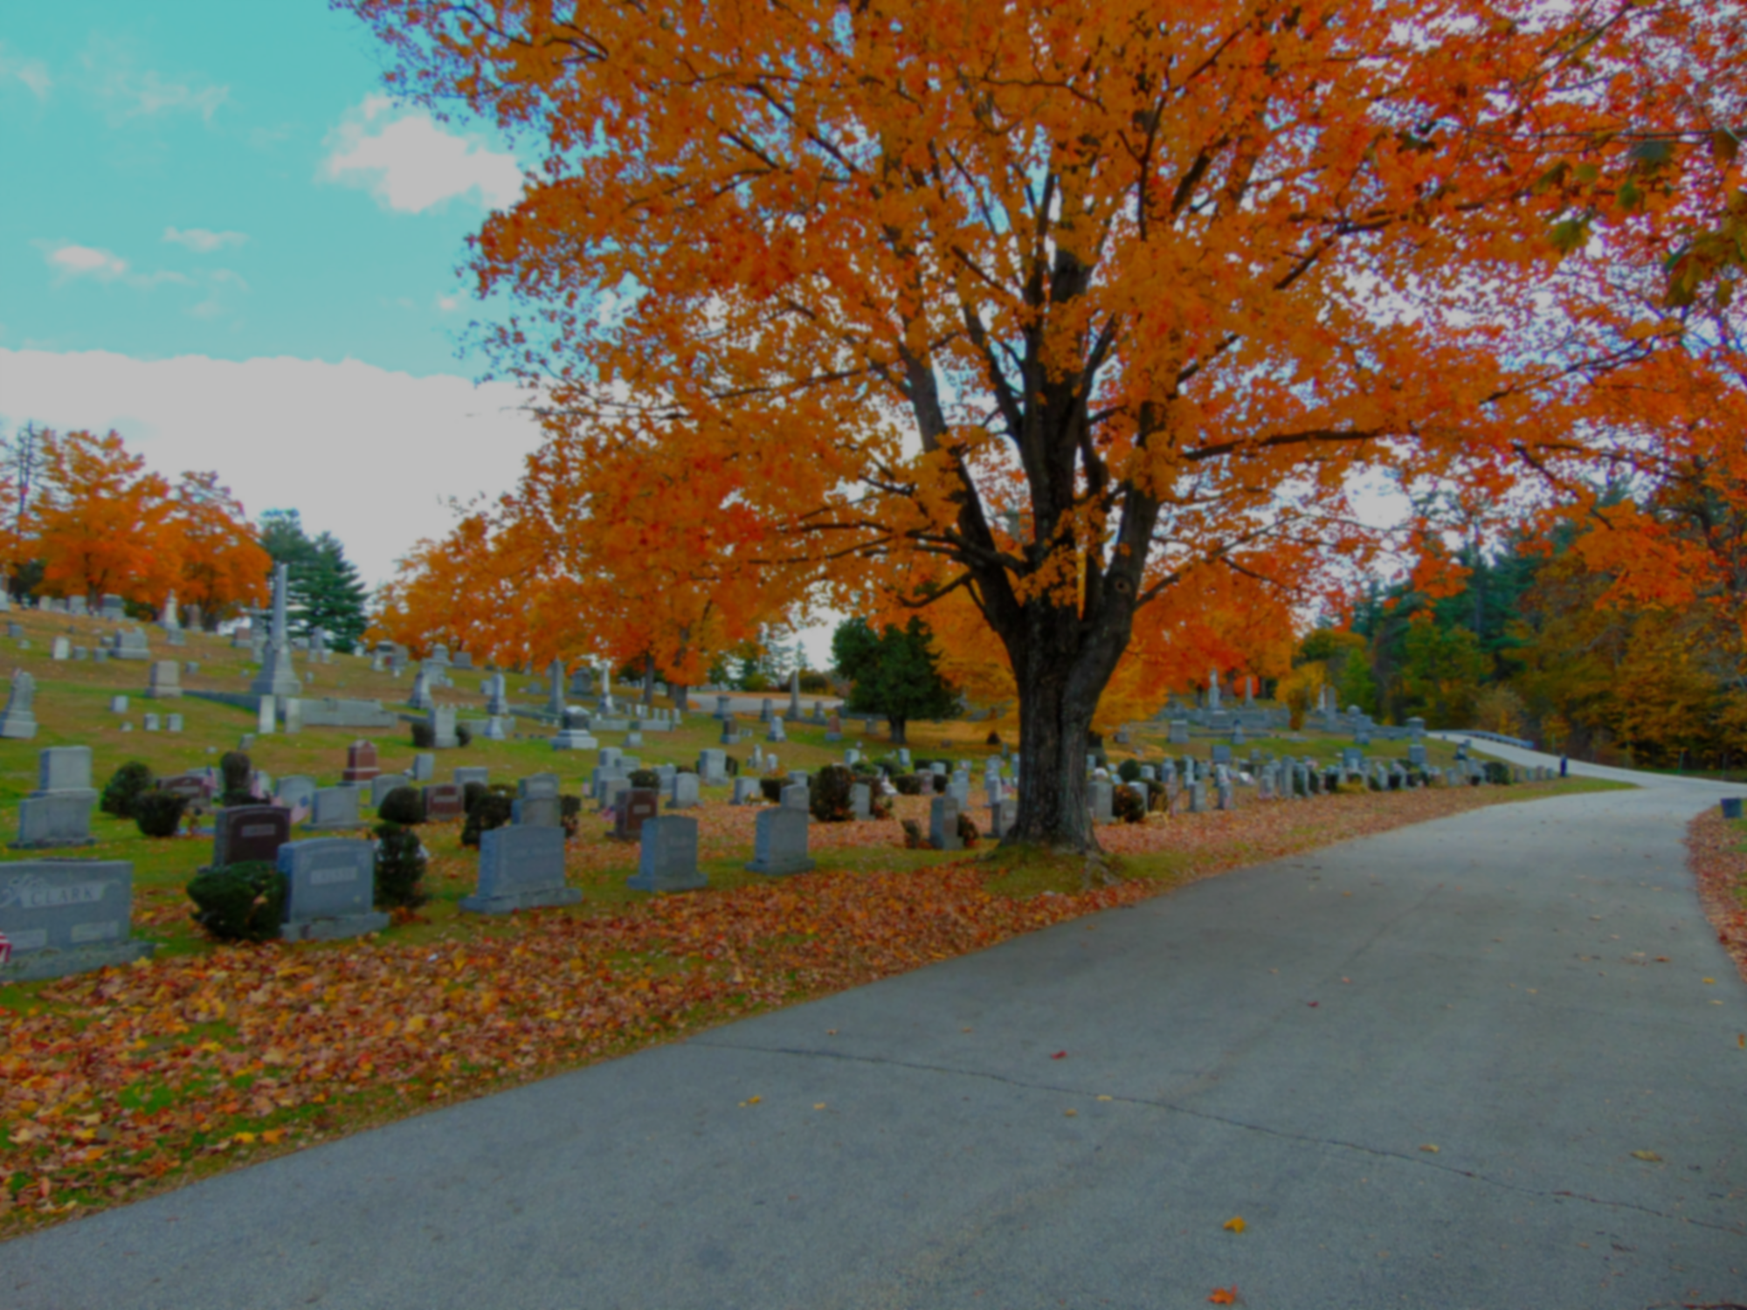

**ESCI 530 Field Geology Project 4:**

**Are graveyards in seacoast NH more common in glaciomarine silt/clay or in glacial till?**

**Abstract:**

The objective of the project is to use Geographic Information Systems to identify whether graveyards in NH seacoast (New Hampshire) are most common in glaciomarine silt/clay or glacial till. The area this was primarily projected was Dover West, Dover East, Newmarket and Portsmouth. These areas represented the NH seacoast and had the highest coverage for both the graveyards as well as the glacial sediments. Through the intersection of graveyards and surficial facies, it is possible to identify the area where they overlapped and filter out the area where the graveyards are placed whether it be in glaciomarine or glacial till. The results gathered showed that within the NH seacoast region, graveyards were more common in glaciomarine silt/clay.

**Introduction:**

The goal of the project is to use Geographic Information Systems to identify whether graveyards in NH seacoast are most common in glaciomarine silt/clay or glacial till. Glacial till is a fine-grained soil, but it also contains sediments of every size that are mixed together (Glacial Till and Glacial Flour). Due to the variety of sediment size, it is resistant to root penetration and doesn't retain water well. It was formed through abrasion where the glacier picked up the material and moved it, all the while carving up the earth and carrying away layers of rock and topsoil. Glacial moraine is the material that was left behind by a moving glacier, so they are usually soil and rock (National Snow and Ice Data Center). The surficial geology in the seacoast consist of either silt or clay. Surficial maps are essential to understand the location of each surficial material, as well as identify the New Hampshire graveyards.

**Methods:**

The first method was adding the NH surficial geology layers, as well as the NH graveyard file into QGIS, to identify the location of each surficial material. The NH surficial geology map displays the unconsolidated materials which are beneath the topsoil layers (Department of Environmental Conservation). The NH graveyard map shows the total graveyard in New Hampshire. With both the layers being added we merged them through QGIS and filtered the surficial geology map so that the only layers visible is the glaciomarine silt and clay and the glacial till. Using the intersection tool in QGIS, the graveyard map was overlapped with the surficial geology map. Through the intersection of graveyards and surficial facies, the overlap area was calculated to compare the area for each facies and also calculate the total area to “normalize” the data. By dividing the total area over the overlapped area, the normalized data was obtained. That data evens out and is then able to be compared to the graveyard area.

**Results:**

Filtering the surficial geology map was the first step into finding the area that is covered by only glaciomarine silt and clay and glacial till. Doing this in QGIS helps show the total area for each of the facies. Using the surficial geology layers, as well as the graveyard layer, an intersection is created to show a new layer that only includes graveyards that overlap the facies. Through the intersection of graveyards and surficial facies, the area is calculated where the graveyards overlap the two types of surficial facies. Glaciomarine facie had a greater number of graveyards built than the glacial till. By dividing the graveyard overlap area by the total facies area, we get a normalized area. The glaciomarine has a higher normalized area of 0.45 while the glacial till has 0.36. This implies that there are around 45% of graveyards built in glaciomarine while only 36% of graveyards are built in glacial till.

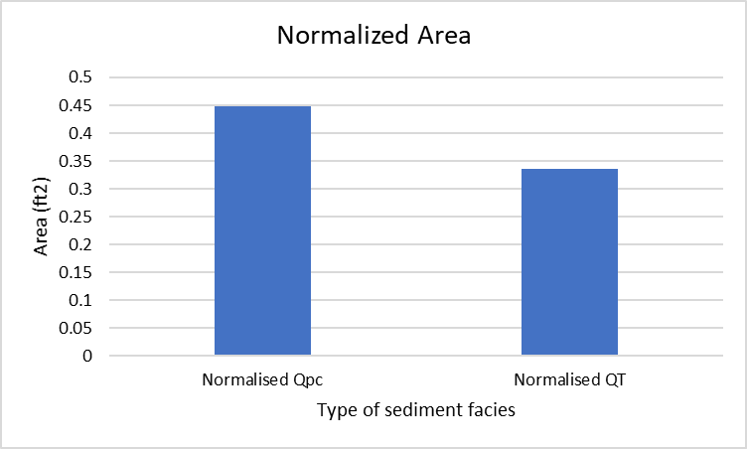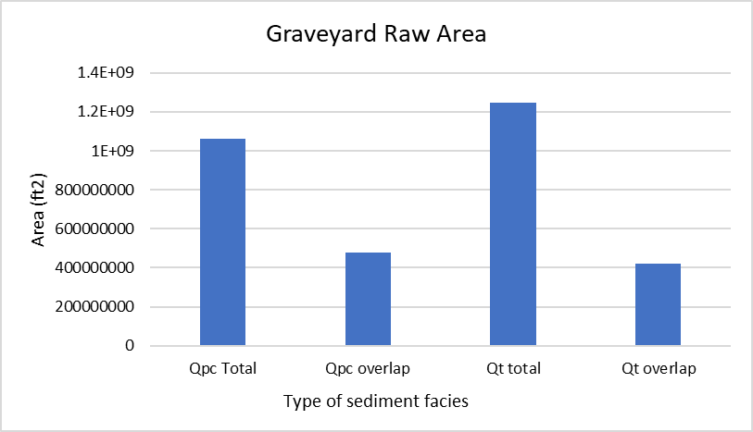

(Graph 1) The Raw area for total number of graveyards in the NH seacoast region as well as the overlapped area.

(Graph 2) The normalized area through dividing the total area over the overlapped area.

**Discussion:**

Glaciomarine silt/clay had a greater number of graveyards than glacial till. Comparing the graveyard areas of the two surficial facies, glaciomarine silt/clay had 9% increase in the total number of graveyards. Bedrock exposures affect the location of graveyards when it comes to digging graves, it is harder to dig as well as to bury. Settlements play a vital role too, graveyards are usually located outside the habitable settlement spaces, but still close to urban towns for people to visit. The size of the land, could either provide a large surface area for burial or limit the capacity for the number of graveyards. Lastly, natural hazards could play an important role in the location of graveyards, tornadoes, hurricanes, mudslides, earthquakes, flooding damage cemeteries.

**Conclusions:**

Through the use of surficial geology maps as well as a map of New Hampshire graveyards to find where they overlap, it was found that graveyards are more common in glaciomarine silt/clay. Glaciomarine silt/ clay is good for air circulation and could be easier to dig because it is fertile. While soil types do play an important role in the placement of graveyards, other factors such as bedrock exposures, natural hazards, and settlements affect the location of where graveyards are built.

(Map 1.) Index Map of the New Hampshire Seacoast Area

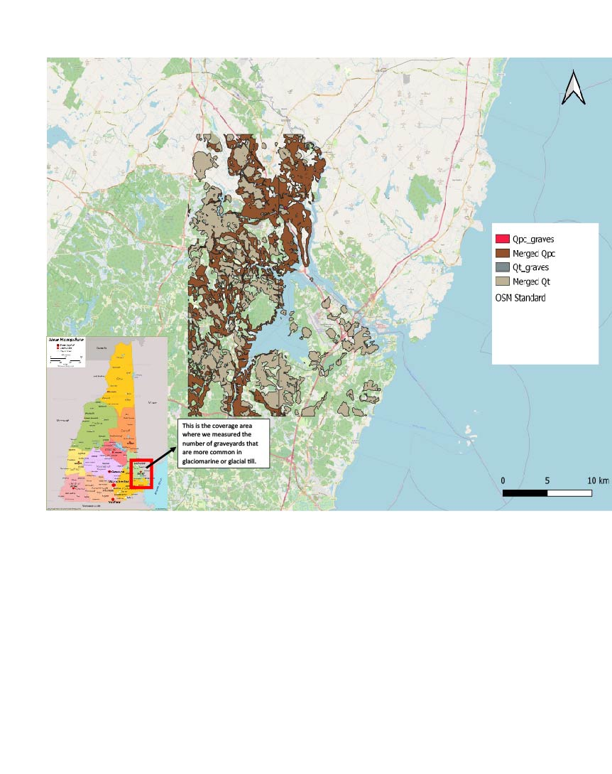

**References:**

National Parks Service. *Glacial Till and Glacial Flour (U.S. National Park Service).* Date accessed October 27, 2021 <https://www.nps.gov/articles/glacialtillandglacialflour.htm>

Glacier Landforms: Moraines | National Snow and Ice Data Center. *National Snow and Ice Data Center.* Date accessed October 27, 2021. <https://nsidc.org/cryosphere/glaciers/gallery/moraines.html>

Maps and Their Uses | Department of Environmental Conservation. *Maps and Their Uses.* Date accessed October 27, 2021. <https://dec.vermont.gov/geological-survey/maps-uses>